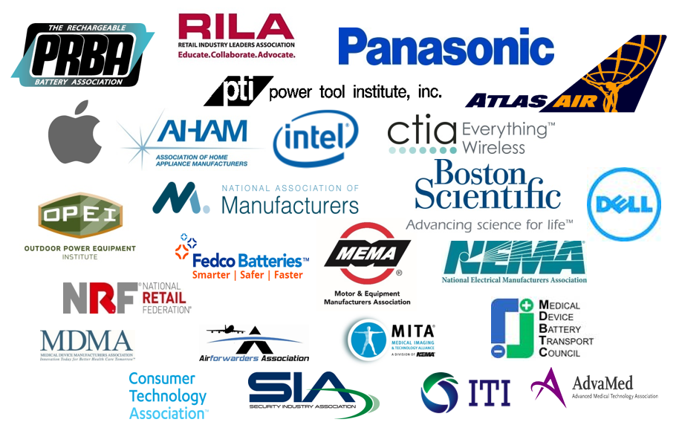

June 26, 2017

Representative Bill Shuster
Chairman, Transportation and Infrastructure Committee
United States House of Representatives
2268 Rayburn HOB
Washington, D.C. 20515

Representative Peter DeFazio
Ranking Member, Transportation and Infrastructure Committee
United States House of Representatives
2134 Rayburn Office Building
Washington, DC 20515

Dear Chairman Shuster and Ranking Member DeFazio:

The Safe Battery/Products Transportation Coalition represents companies and associations of companies that manufacture, use, and transport lithium cells and batteries and products containing them. Those products include laptops, cellular phones, portable music/video devices, navigation/GPS systems, cameras, smoke/security alarms, hybrid electric and all-electric vehicles, power tools, pacemakers, defibrillators, spinal cord stimulators, portable oxygen concentrators and blood glucose monitors. The lithium cells and batteries industry provides tens of thousands of jobs and billions of dollars of economic contribution to the U.S. economy.

The Coalition wholeheartedly supports the policy approach to lithium cells and batteries in Section 609 of H.R. 2997. Coalition members take very seriously the shipping of lithium cells and batteries and products containing them and appreciates the leadership Chairman Shuster has shown in encouraging safety without disrupting supply chains or increasing consumer costs.

Proposed H.R. 2997 contains several essential provisions:

- Section 609(e) will assure industry participation in all panels and working groups of the International Civil Aviation Organization (ICAO) Dangerous Goods Panel and any other international test or standard setting organization in which the United States participates, which is essential to providing those organizations with technical information and expertise, notwithstanding recent efforts by some ICAO staff to limit such participation.

- Consistent with Section 828 of the FAA Modernization and Reform Act of 2012, and to avoid burdensome, patchwork regulations, Section 609(f) requires U.S. regulations be harmonized with ICAO standards.

- Section 609(b) creates a Lithium Battery Air Safety Advisory Committee to ensure, among other things, transparency in the development of the U.S. position before ICAO meetings.

- Section 609(c) provides the Secretary of Transportation with authority to authorize the shipment on passenger aircraft of batteries used to power medical devices in circumstances where a destination cannot be reached by commercial cargo aircraft and a patient needs life-critical batteries.

The Coalition encourages the Committee to include in any bill it reports the language proposed in Section 609 of H.R. 2997as promptly as possible.

Respectfully,
Safe Battery/Products Transportation Coalition

*** The members of the Safe Battery/Products Coalition include the Aitforwarders Association, Association of Home Appliance Manufacturers (AHAM), Apple, Atlas Air, Boston Scientific, CTIA, Dell, Fedco Batteries, Information Technology Industry Council (ITI), Intel, Medical Device Battery Transport Council (MDBTC), Medical Device Manufacturers Association (MDMA), Medical Imaging and Technology Alliance (MITA), Motor and Equipment Manufacturers Association (MEMA), National Association of Manufacturers (NAM), National Electrical Manufacturers Association (NEMA), National Retail Federation (NRF), Outdoor Power Equipment Institute (OPEI), Panasonic, PRBA – The Rechargeable Battery Association, Power Tool Institute, Inc. (PTI), Retail Industry Leaders Association (RILA), and Security Industry Association (SIA).

